COLLEGE ASSITANCE PROGRAM
CAP ADVISOR: MS. SANZ
ssanz@dadeschools.net
@Gables_CAP

The College Assistance Program (CAP) is a postsecondary advisory program to increase equitable college outcomes for all students. As the CAP Advisor, I’m here to help you navigate through the college process. To stay up to date with all things CAP, make sure to visit the CAP Corner on CavsConnect.com
IMPORTANT CAP INFO:
- If you wish to contact me, or request a parent meeting, please send me an email at ssanz@dadeschools.net.
- Students may request a meeting using this QR code:
- SCOIR: All students must have a registered Scoir account. The student must invite you in ordered to create a parent account.
- Upcoming SAT/ACT Dates:
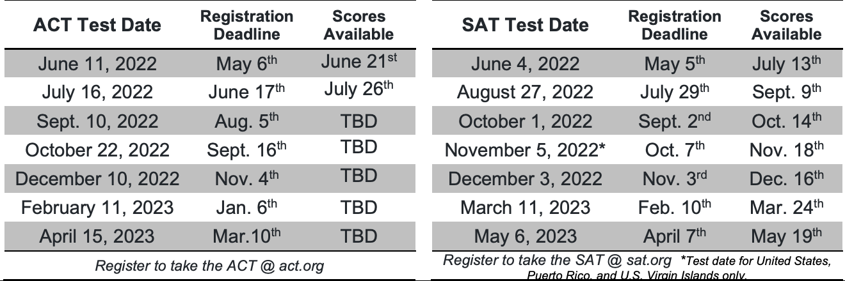
  - COST- SAT: $60, ACT: $65
  - With a fee waiver, both exams are FREE
- To qualify for an exam fee waiver, you must first qualify for free or reduced lunch. Please fill out the MDCPS Income Survey to see if your student qualifies. Scan this QR code for a link to the survey.
  - Please wait about 2 weeks for the results to upload into the system, then students can come see me in room 6111 to receive their waiver.
GRAD TRACK:
Students and parents can check their own progress and requirements for graduation
Grad track can be found on the student and parent portals under student info- reports or on the Dade schools app.
Information found on Grad Track:
- GPA, community service hours, summary of graduation requirements and how much they have completed

