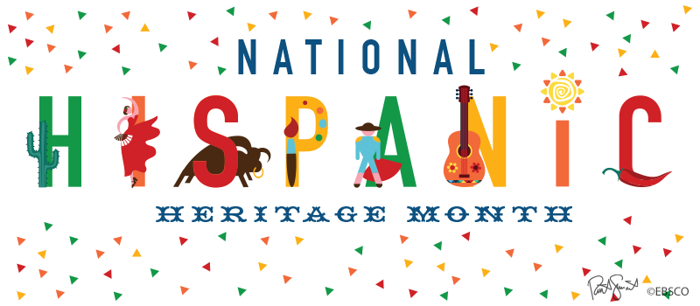
Do you have any talent?
Can you sing or play a Spanish song or dance Rueda, Tango or other folkloristic Spanish dances? Maybe you are great at acting! Or is there a chef inside you?
Whatever your case might be, this is your moment!!!!
- Hispanic Heritage show , Friday, October 28th

- Hispanic Cooking Contest, Wednesday October 26th -see instructions and QR code on Cooking contest flyer.

- Art showcase, Oct. 28th, covered walkway behind the library. See Ms. Chapman in room 2162

Why: 1. FUN!
2. Prizes!
3. Community Service Hours!!!!
-10 h. for the organization for members of Spanish Honor, French Honor societies, or ESOL Club
-15h. for participating in the Cooking Contest
- 20 h. for performance at the show
LAST Show AUDITIONS: Monday, October 17th
After school, room 9209- Results on October 18th
Additional questions? Visit room 9209, 9213, or 2162

