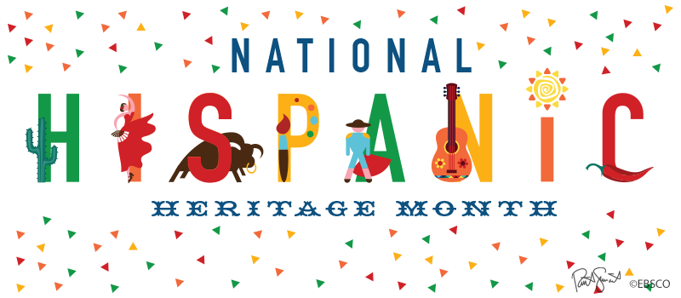
COOKING CONTEST GUIDELINES AND APPLICATION

The contest will take place on Wednesday October 26th during both lunches in the Teachers’ lounge. The faculty and staff will serve as the judges during both lunch waves.
Your dish must serve 10-15 regular portions and represent the Hispanic culture. One dish per participant.

In the morning before 7:15am, drop off your dish in the Teacher’s lounge. Members of the Spanish/ French Honor societies will be there to assist you. There is no need to warm it up.

To present your dish, you must design an attractive small poster board in English with:
- The name of your dish
- The country of origin
- The recipe
- A few lines explaining why you chose to cook this dish. What does it represent for you?
Feel free to make it as attractive as possible as this will be one of the components that will be voted on.

The faculty and staff will be asked to vote on the following criteria:
- Taste
- Appearance
- Execution
- Presentation (your small poster board)
Each approved participant will be awarded 15 hours of Community Service hours.
The winner will also get a $25 Amazon Gift card.

_________________________ SCAN QR CODE TO ENTER THE COOKING CONTEST_________________________
