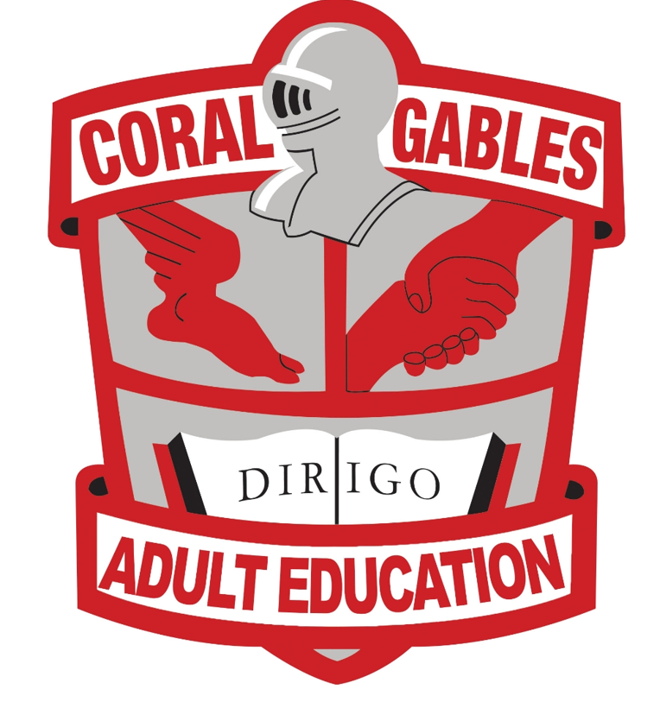

Join us for a Fun Exciting Adventure!
An Evening Expo in the Gables

Register and get your Passport to:

Citizenship

DANCE

ESOL

GED

High School Completion

Thursday, October 7, 2021

5:30pm to 8:00pm

Coral Gables Adult Education Center

450 Bird Road
Park in the back of the school by building 9

Music, Dance, DJ, Face Painting, Refreshments, GSH JROTC Color Guard, Gablettes, Select Band Performance, Face Mask required
CGABLESADULTINFO@GMAIL.COM

