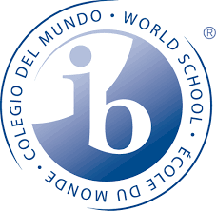
Bridge for Peace 2018-19 Project Application

Application forms are due September 28th by 2:00 in Room 9319.

Contact Information
Name
ID
Grade
1st Period
2nd Period
Phone
E-Mail Address

Basic Questions
What is the name of your cause? (Optional)
What country or region is your cause targeting?
What is the approximate fundraising goal for this project?
How will the raised money be used?
Are you working with an organization? If so which one, and is it nonprofit?
If it is not nonprofit what percent of money given goes directly to the cause?
Does the organization that you are working with have a bank account in its name?

Your contacts information
In order to be eligible to be considered for the 2018-19 Bridge for Peace event, you need to be in close contact with a member of the organization. Enter your contact’s information below:
Name
Work Phone
Email

Your Cause

Briefly explain the importance of your cause, as well as why it should be selected. Describe any personal relationship or motivation you have regarding the cause.

Presentation
Applicants must present their cause to the IBHS Board and be prepared to answer questions. Your presentation must have a PowerPoint, they should be no longer than 5-7 minutes. An IBHS board member will contact you to schedule the presentation within 48 hours of reviewing your application.

Agreement and Signature

By submitting this application, I affirm that the facts set forth in it are true and complete. I understand that if I am accepted as a cause, any false statements, omissions, or other misrepresentations made by me on this application may result in my immediate dismissal.
Name (printed or typed)
Signature
Date

Questions
If you have any questions or concerns please contact the IBHS President, Emily Simon, at emilybsimon@gmail.com

