**PRE-ORDER YOUR JUNIOR HOODIE!!**

**$20**

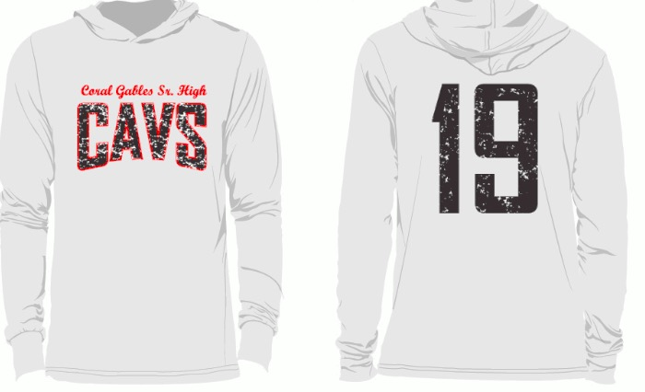

**WHITE**

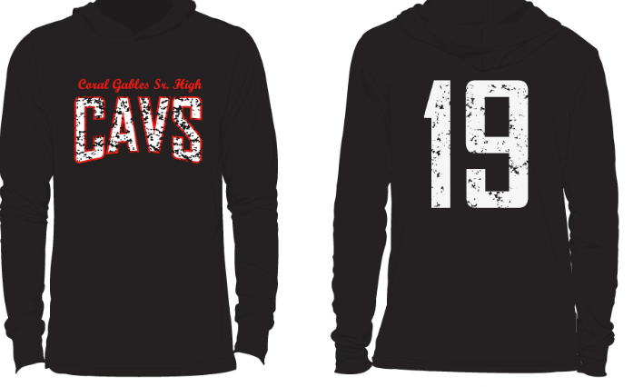

**BLACK**

NAME: _______________________ ID#:___________________

ENGLISH TEACHER: _______________________

BLACK:________WHITE:_______ SIZE:____ TOTAL $_____