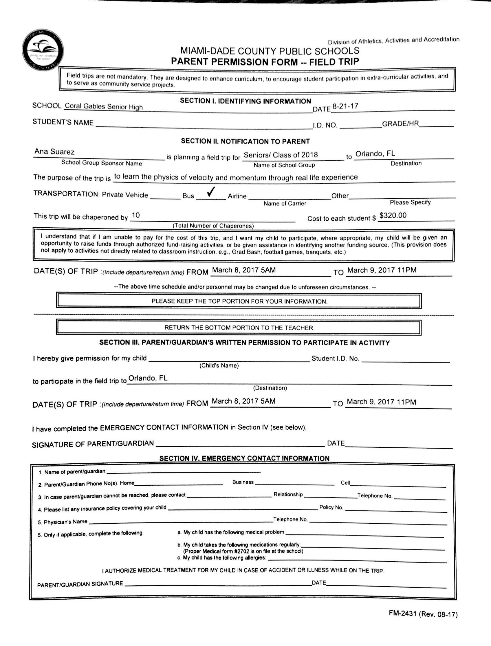

RESPONSIBILITY ACKNOWLEDGEMENT FORM
GradBash 2018

I, ___________________________, the parent or guardian of __________________________, understand that I am responsible to pick up my child if they get arrested while on the Grad Bash field trip and that the school will not wait for my child. I also understand that if my child breaks the 10/20 rule any time before the bus leaves for the trip, my child will not be allowed on the trip and will not be reimbursed the $320.

________________________ ________________________ _________
Parent printed name Parent signature Date

________________________ ________________________ _________
Student printed name Student signature Date

