SENIOR GEAR!
NAME: __________________________________
ID NUMBER: ____________________________
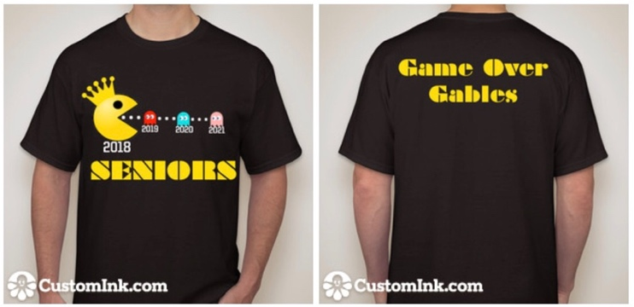
PAC-MAN SHIRT SIZE
$15 XS _____
S _____
M _____
L _____
XL _____

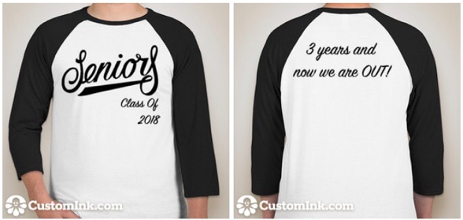
CLASSIC SHIRT SIZE
$15 XS _____
S _____
M _____
L _____
XL _____
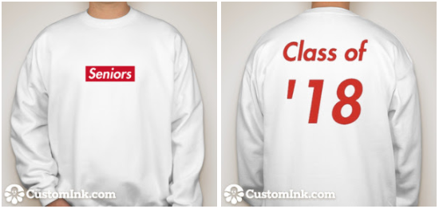
SUPREME PULLOVER SIZE
$15 XS _____
S _____
M _____
L _____
XL _____
SWEATPANTS
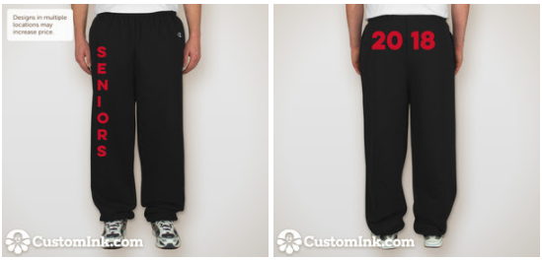
SIZE
$15 XS _____
S _____
M _____
L _____
XL _____

TOTAL ITEMS: ______________
TOTAL AMOUNT: $__________

