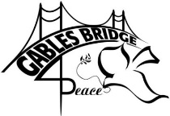
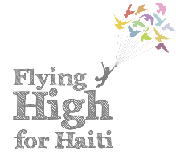
Bridge for Peace International Dinner
Donation Form
The Coral Gables Senior High School International Baccalaureate Honor Society is sponsoring the 2016 Bridge for Peace event. The event will be an international cuisine dinner with entertainment held on March 31st, 2016 from 6:30pm-8:30pm. Our goal is to raise $12,000 to fund the construction of two new classrooms on the island Île-à-Vache just off the coast of Haiti. To reach our goal, we ask for donations of a minimum of $20 to the cause. $20 guarantees you 10 food tickets to redeem the day of the event and to use towards the buffet dinner. It will also guarantee you a B4P t-shirt. Special recognition will be given at the event for donors giving more than $100. Gold Member: $500, Silver Member: $300, Bronze Member $100. Thank you for your support in fulfilling the international component of our IB program and positively impacting our global community.
Collection dates are February 23rd, 24th and 25th during both lunches in outside the Ralph Moore Building.
Donor’s Information:
Name:
ID Number:
Cell Phone Number:
Email Address:
Are you an IBHS member?:
Grade Level:
Shirt Size:
Amount Donated:
Additional Donor’s Information:
Name:
Cell Phone Number:
Email Address:
Shirt Size:
Amount Donated:
Additional Donor’s Information:
Name:
Cell Phone Number:
Email Address:
Shirt Size:
Amount Donated:
Additional Donor’s Information:
Name:
Cell Phone Number:
Email Address:
Shirt Size:
Amount Donated:
*Donations can be made in cash or checks made out to “CGHS PTSA” with Bridge for Peace 2016 written in the memo*
Total Amount Donated:

