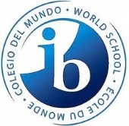
Inductee Membership Application
The International Baccalaureate Honor Society invites you to apply for membership for the 2015-2016 school year. Please print legibly and return this application October 28th during the first IBHS meeting or October 29th or 30th in front of the New Building during both lunches. With the application, you must turn your application fee of $20.00 that includes a pre ordered t-shirt. Failure to fulfill the requirements will result in denial of induction. Membership is open to ALL pre-IB and IB students.
Basics
Name (Last name, First name): ___________________________________ ID #: _____________
Gender: __________ Grade Level: _______ Shirt Size: _______
Contact Information
Email: _____________________________________ Phone Number: __________________

Schedule
Period | Teacher | Subject | Room Number
1.
2.
3.
4.
5.
6.
7.
8.

Signature: _________________________________ Date: ________________________

