**UPDATED CGHS Senior Gear Pre-Order Form!**

Name: ID #:

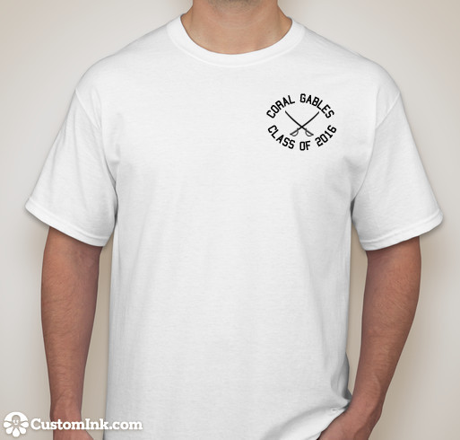

Price: $12

☐ Small

☐ Medium

☐ Large

☐ X Large

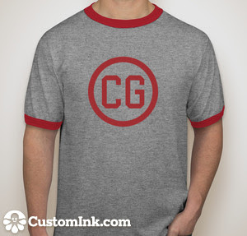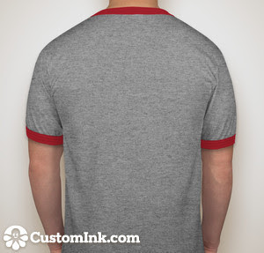

Price: $15

☐ Small

☐ Medium

☐ Large

☐ X Large

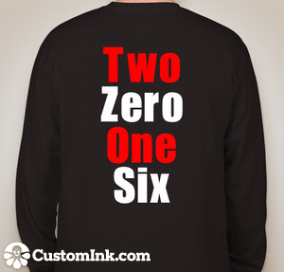

Price: $15

☐ Small

☐ Medium

☐ Large

☐ X Large

Price: $25

☐ Small

☐ Medium

☐ Large

☐ X Large

*The “Gables” will be printed differently

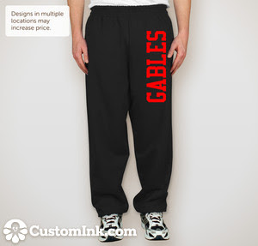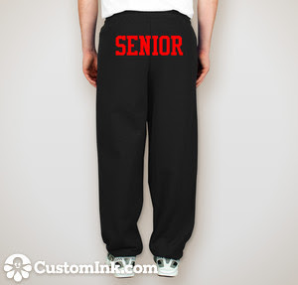

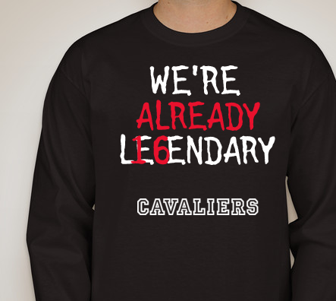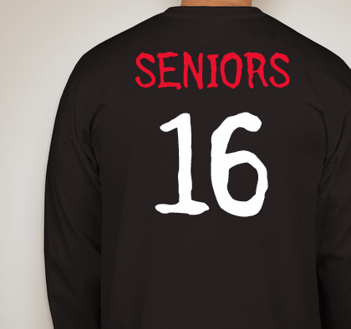

Price: $20

☐ Small

☐ Medium

☐ Large

☐ X Large

Price: $20

☐ Small

☐ Medium

☐ Large

☐ X Large

