**CGHS Senior Gear Pre-Order Form!**

Name: ID #:

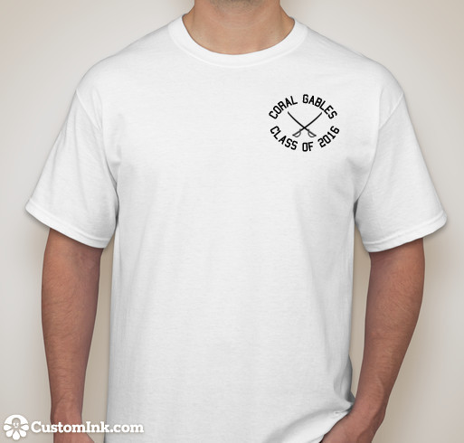

Price: $12

☐ Small

☐ Medium

☐ Large

☐ X Large

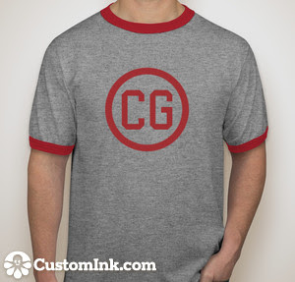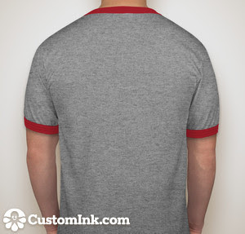

Price: $15

☐ Small

☐ Medium

☐ Large

☐ X Large



Price: $15

☐ Small

☐ Medium

☐ Large

☐ X Large

Price: $25

☐ Small

☐ Medium

☐ Large

☐ X Large

*The “Gables” will be printed differently

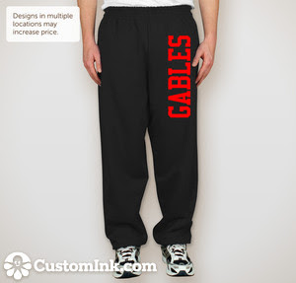

Note: Collections will be on September 10th and 11th during both lunches in the Activities room (Room 9219). Cash only. Please write your name and ID number at the top of this page.