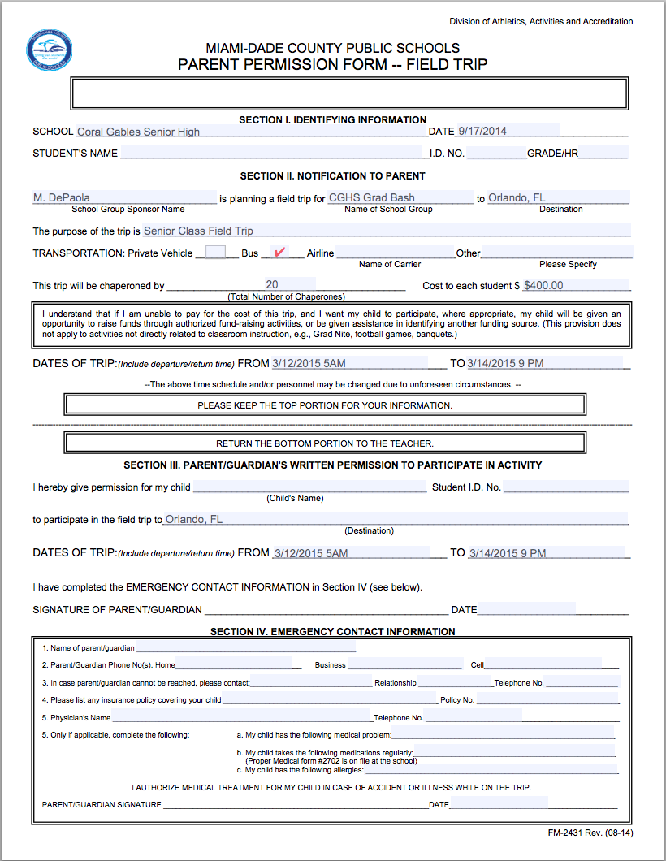
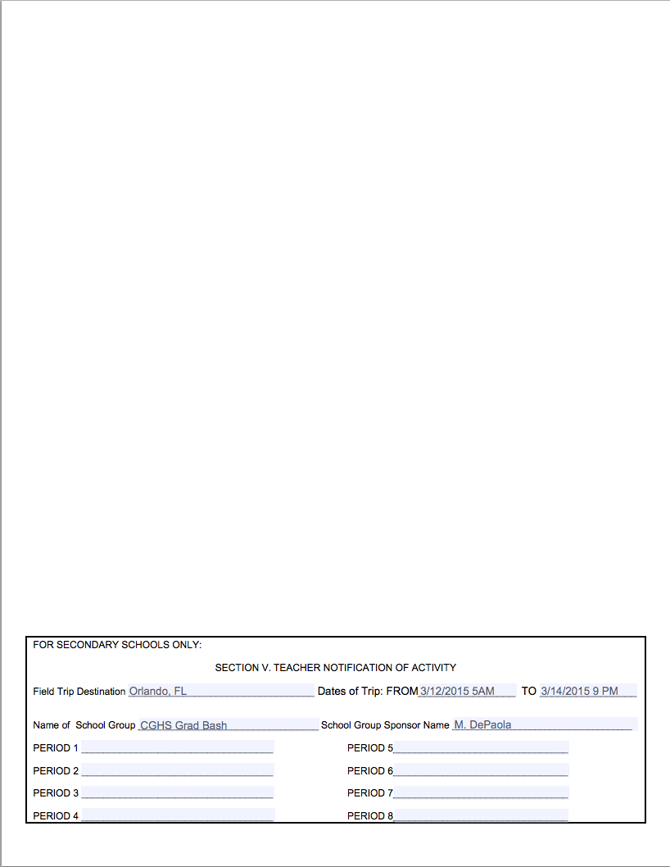
I hereby understand that if my son/daughter is arrested during the Senior Class Field Trip, it is my responsibility to handle the situation. Once my son/daughter is taken into police custody, Coral Gables Senior High School is not responsible for my son/daughter and all transportation issues must be handled through me and my son/daughter. I also understand that after the payment for Grad-Nite is made there will be no refunds of any kind.

X ____________________________________________
Print Name of Parent/Guardian

X ____________________________________________
Signature of Parent/Guardian

