Coral Gables Senior High School
Class of 2016 T-Shirts
Name:
Student ID:
Period 1 Teacher:
Phone Number:
E-mail:
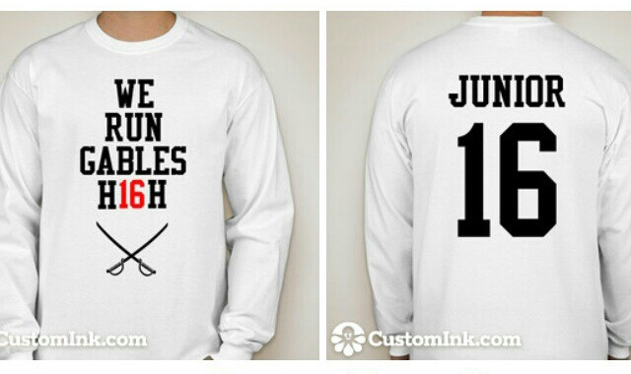
Price: $15.00
Extra-Large
Large
Medium
Small

Price: $13.00
Extra-Large
Large
Medium
Small

Total Amount Due: __________
*All shirts come in ADULT sizes.*
Flyers must be returned to Ms. Monzon’s room (3129) during lunch by October 3, 2014.

