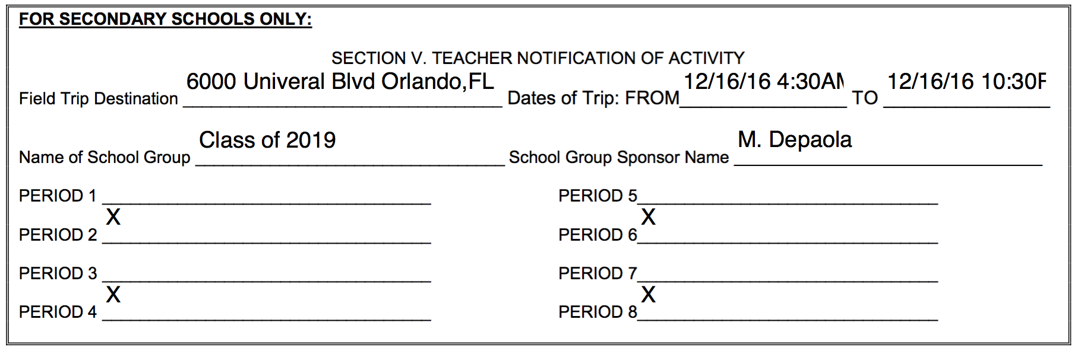
I hereby understand that if I behave inappropriately during the 2016-2017 Sophomore Class Trip to Universal Studios/ Islands of Adventure on December 16th, it is my parent’s responsibility to handle the situation with Universal Orlando. If a problem arises, Coral Gables Senior High School is not responsible for my behavior and all transportation issues must be handled through my parent/guardian and I. I also understand that after the payment for the Sophomore Class Trip to Universal/ Islands is made there will be no refunds of any kind. Also, if I have proof of a Universal annual pass that is valid, I agree that the cost will be $50. If I forget the annual pass on the day of the trip, no refunds will be given, and Coral Gables Senior High School will not be responsible for my admission to the park, and any issues must be handled through my parent/guardian and I. Once I pay and chose my bus, I am not allowed to switch buses. Should I need special medication I will have made it known to Ms. Depaola by Dec. 7th.
X ____________________________________________
Print Name of Parent/Guardian
X ____________________________________________ ________________
Signature of Parent/Guardian Date

X_____________________________________________ ________________
Student Signature Date

