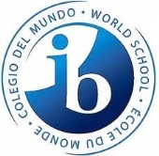
Inductee Membership Application
The International Baccalaureate Honor Society invites you to apply for membership for the 2014-2015 school year. Please print legibly and return this application October 16th during the first IBHS meeting or October 20th or 21st in front of the New Building during both lunches. With the application, you must turn your application fee of $20.00 that includes a pre ordered t-shirt. Failure to fulfill the requirements will result in denial of induction. Membership is open to pre-IB and IB students with a minimum 3.0 GPA.
Basics
Name (Last name, First name): ____________________________________ ID #: ___________
Gender: ___________ Grade Level: _______ Unweighted GPA: _______ Shirt Size: _______
Contact Information
Email: _____________________________________ Phone Number: __________________

Schedule
Period | Teacher | Subject | Room Number
1.
2.
3.
4.
5.
6.
7.
8.

Signature: _________________________________ Date: ________________________

